**Build and Test: Stepping Stone 6**

Build Process

Following my build procedure, I first documented all of my parts to make sure that I had everything that I needed. This was the first board I would be trying to use a toaster oven to solder on the surface mounts. In preparation for that, I took some extra 0805 SMD resistors and placed them on an extra PCB to experiment with temperature and “cook” time. I found that about 3-4 minutes at 410°F (putting the board in when the oven is cold) does the trick. There was a little uneven heating, so some of components looked a little more “toasted” than others. But none of the components performance were affected. I spent a good amount of time applying the solder paste through the stencil to make sure that I had the goldilocks quantity of solder paste to ensure binding while avoiding bridging. I placed all the surface mount parts to find that I had the wrong footprint for the current sense resistor. The footprint was too small, but thankfully, I had placed the pad right next to the inductor pad that it directly connected to. So, I soldered across that pad. I realized that I had the wrong inductor footprint right after we ordered the boards, so I made sure to choose an inductor with leads that I could maneuver into the right position later. After the board cooled after being baked in the toaster oven, I finished soldering on the connectors and their related parts with the solar panel and lithium ion battery. The board was finished being built at this point.

Test Process

Before hooking any power up to the circuit, I checked on the connections on the board using a continuity test on a multimeter – paying special attention to the connections between power and GND. Seeing these all checked out according to my KiCad schematic, I hooked up the lipo battery to verify the connectors fit. Within a millisecond of touching the connector, a little wisp of smoke escaped from one of the traces. Where the trace used to be, now lay a black line. Initially, I thought that the only thing that fried was the trace, since it came before any ICs. I cut out the burnt trace, and replaced it with a new wire with an LED in series to ensure that a flow of current in that direction wouldn’t blow another trace or any other components. With the LED in place, I took my project outside. I first measured the open voltage of the solar panel (10.7V) and the voltage of the battery (7.2V), then proceeded to attach the solar panel to the charging circuit, followed by the battery. Paying special attention to the ICs and they’re temperature, I then took the voltage at each of my test points. Everything seems good heading into the IC, but coming out had some issues. The indicator LEDs were not coming on to indicate charging, and the voltage at the output of the IC was at **0.97V** instead of the anticipated **8.4V.** With Dr. Frohne’s help, I discovered that I not only had a burnt trace from before, but also a burnt Mosfet – shorted between the gate and source. The reason for why hooking up the battery first caused a surge of current in my charger circuit and thus burning my mosfet IC is still being investigated. I will be contacting the texas instruments engineers for additional help, as well as ordering a new Mosfet IC.

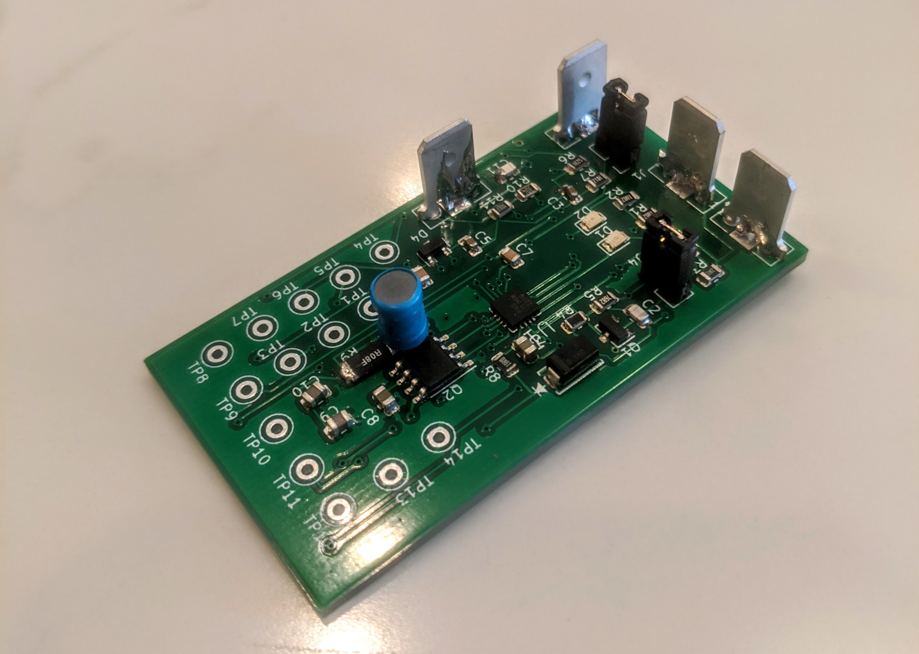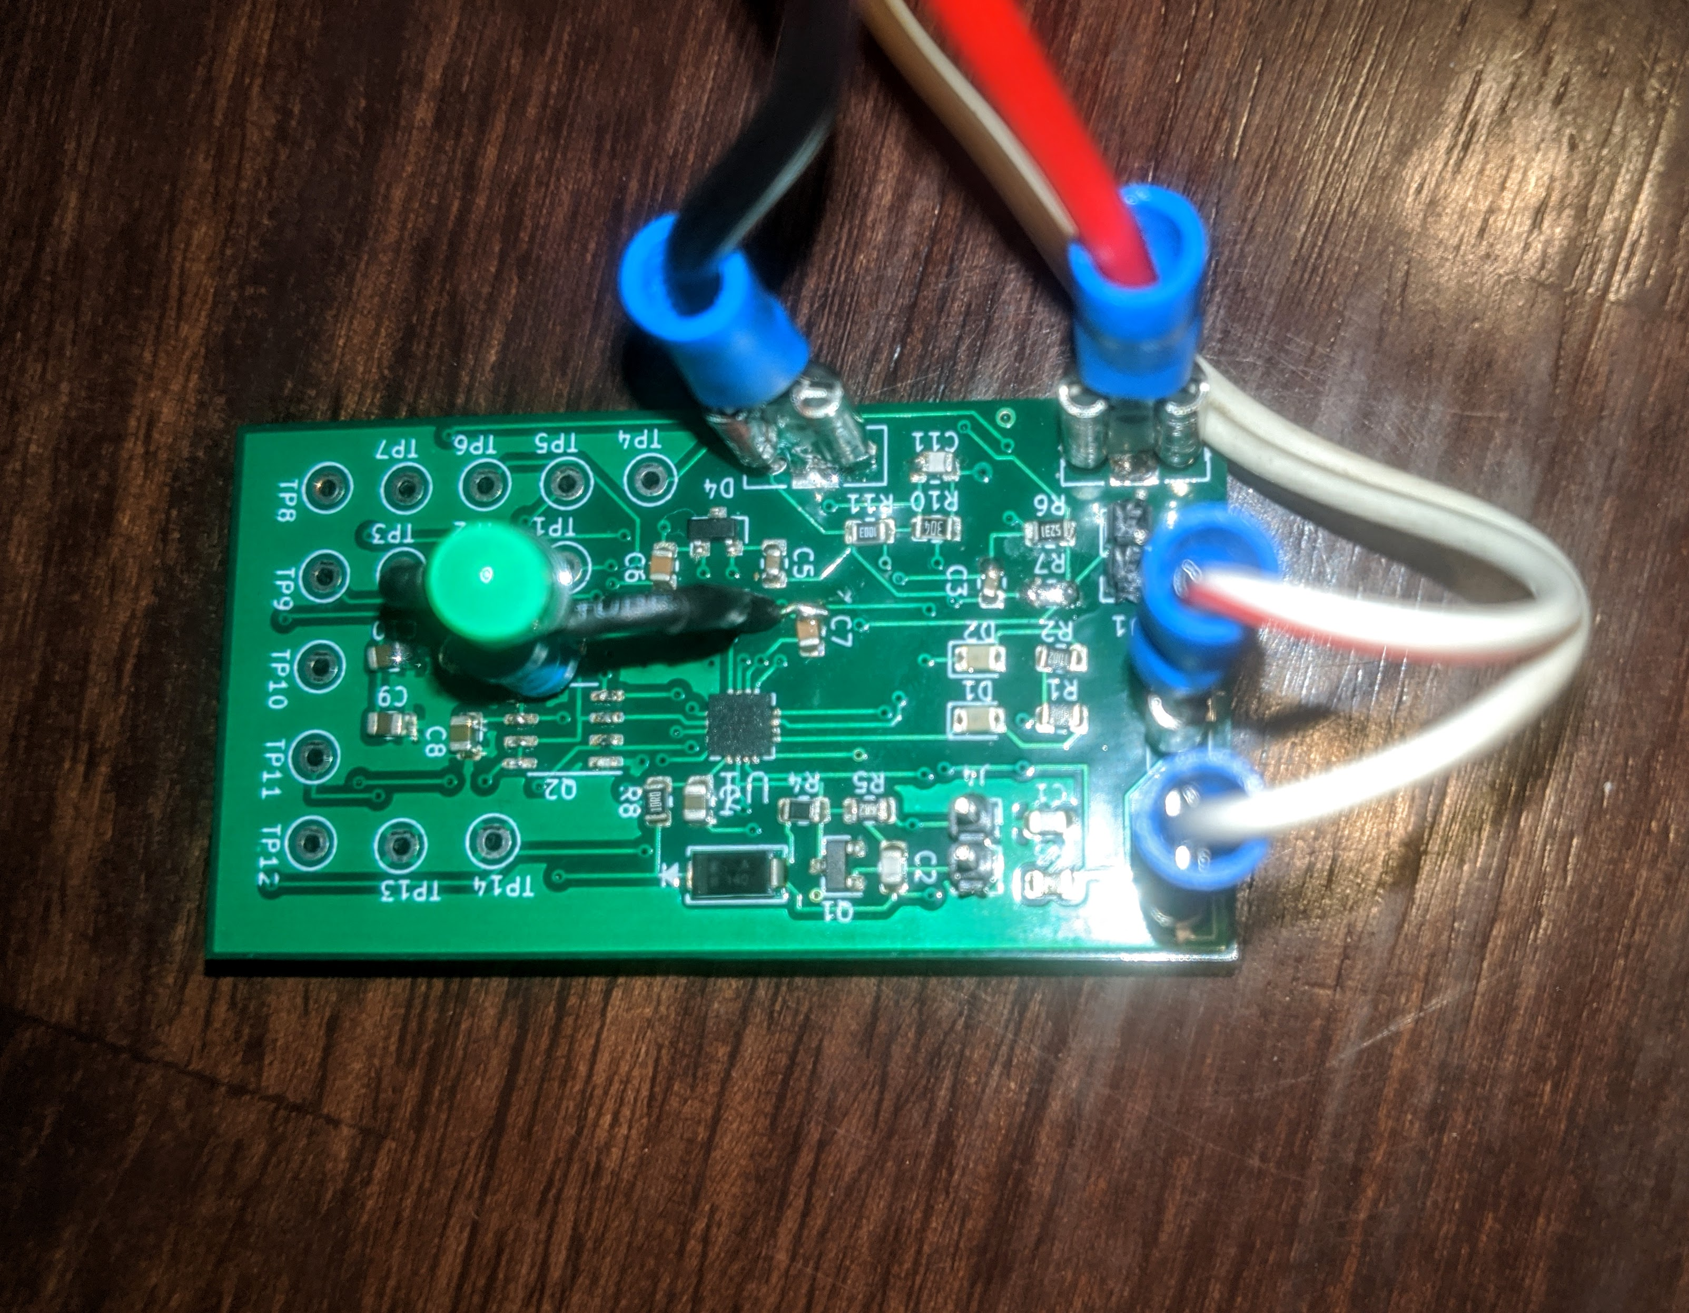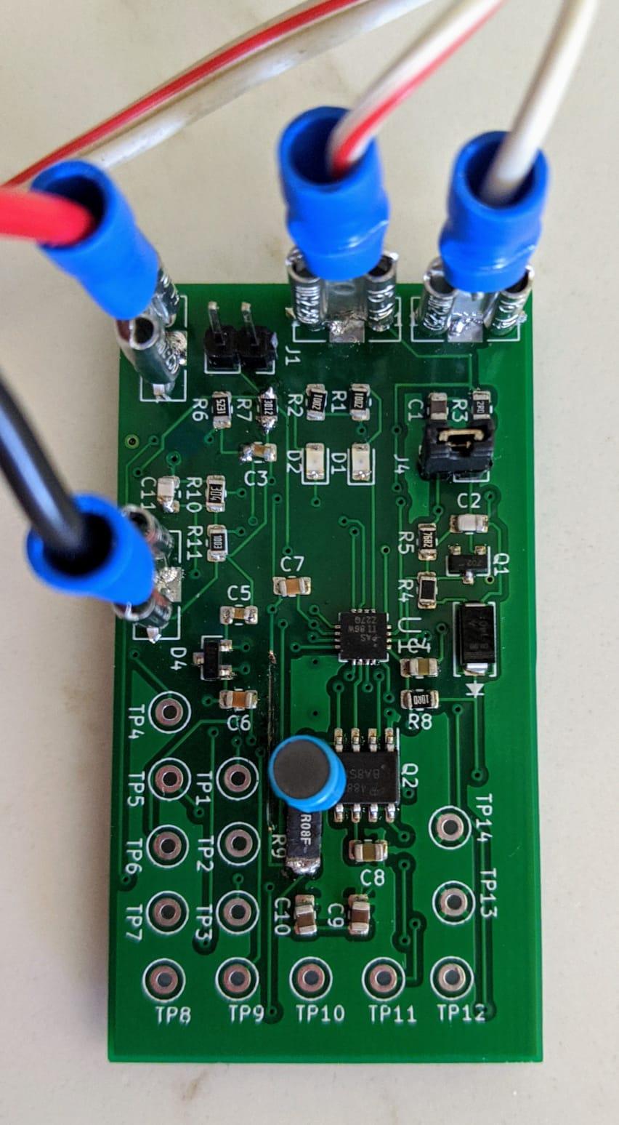Pictures of the build and test process are shown below:

Figure 4. Led inserted in place of burnt trace. Mosfet removed to verify if it was indeed fried or not.

Figure 2. Picture of board with trace burnt

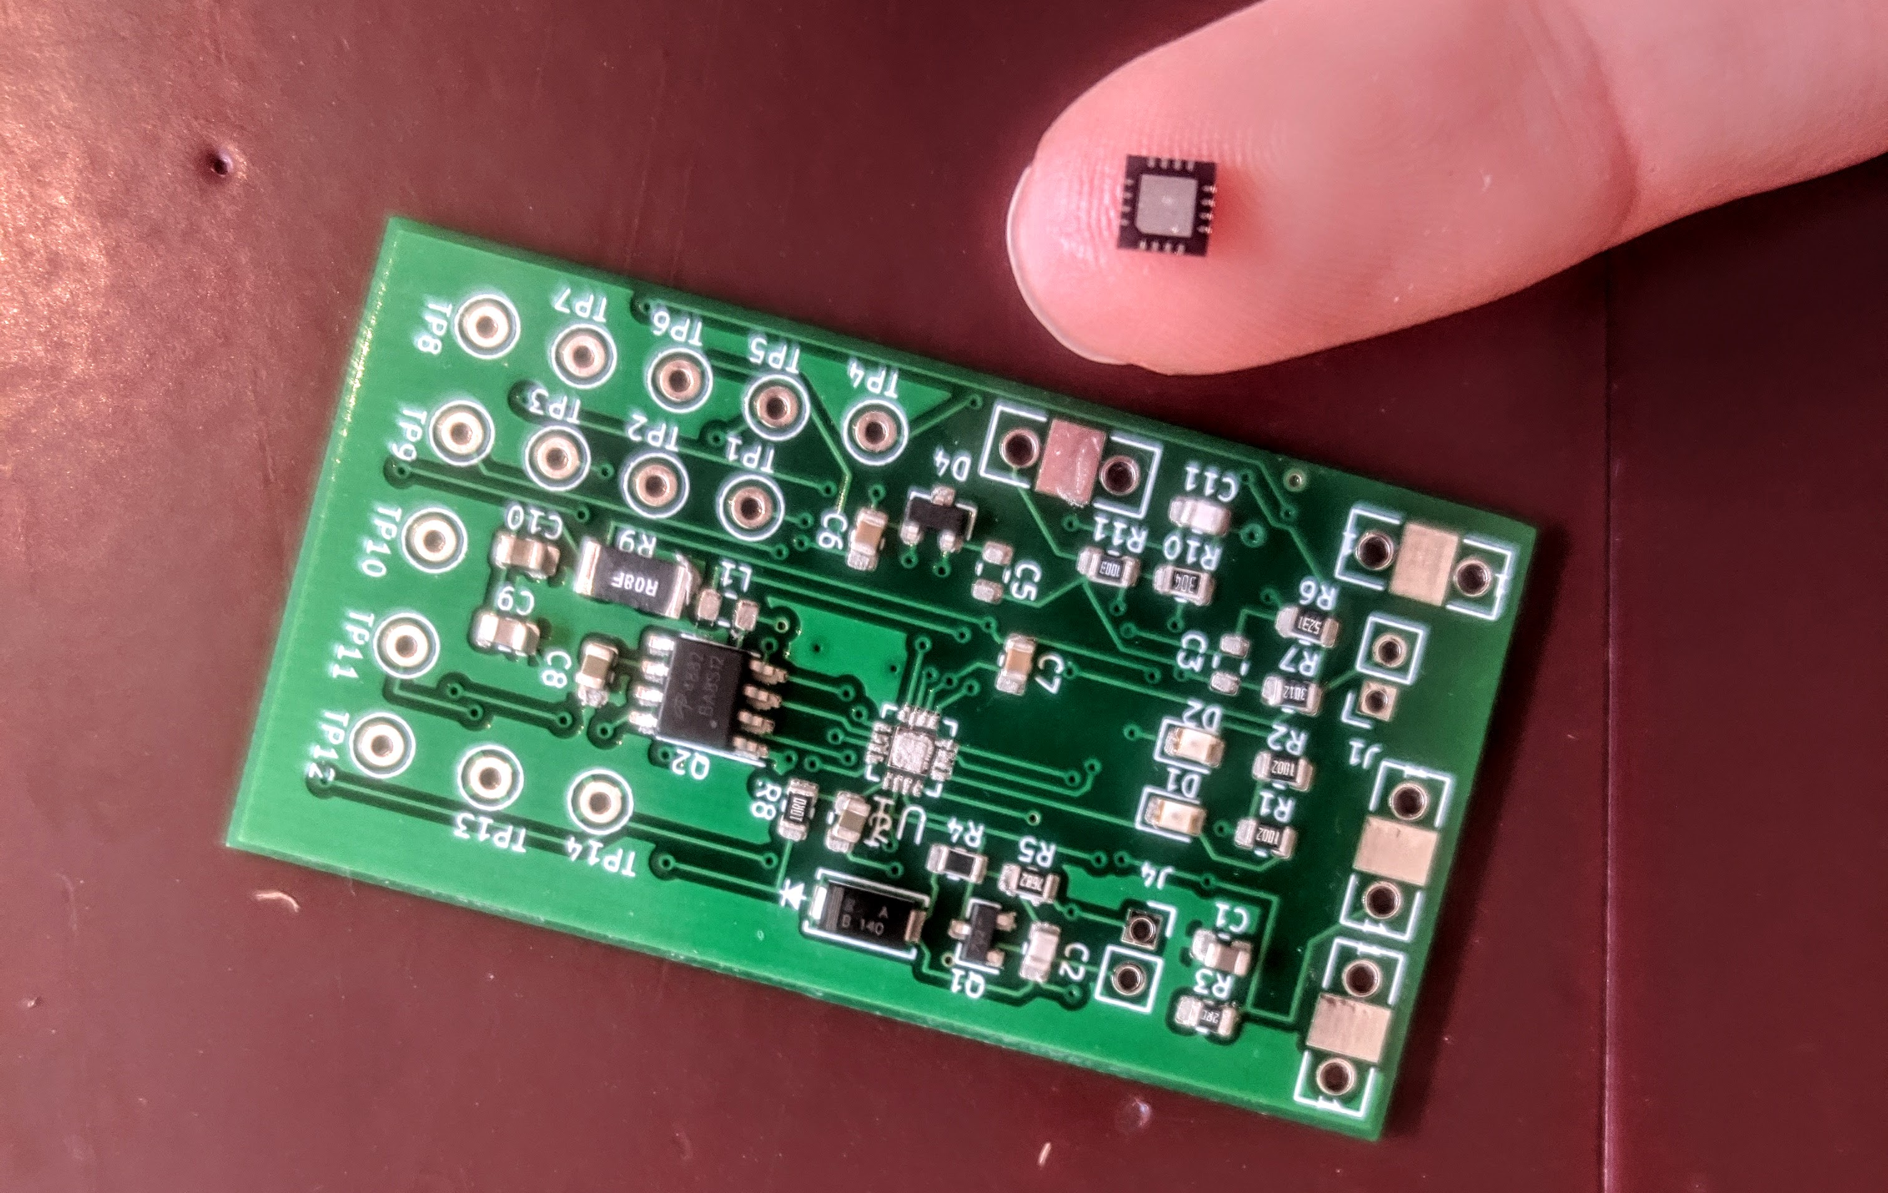

Figure 3. Finished board after hand soldering on connectors and inductor

Figure . Placing Parts before soldering them on. Showcases size of primary IC

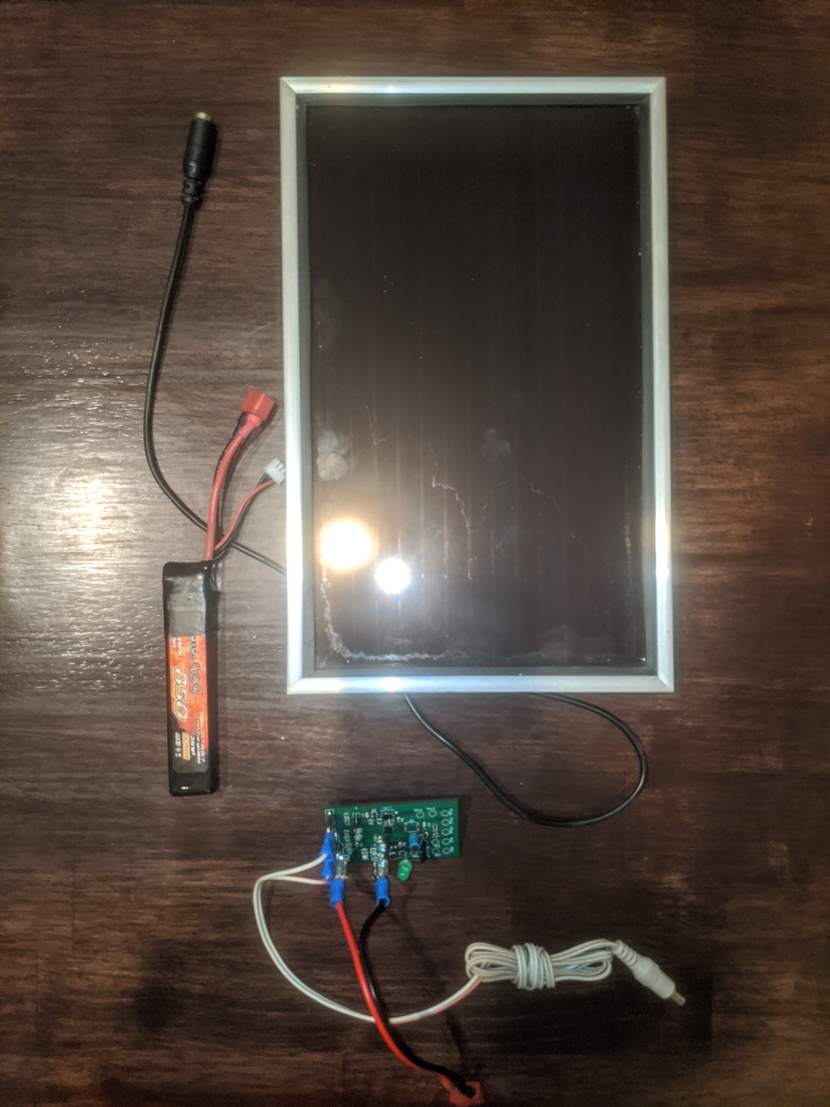

Figure 5. Complete Set-Up: Solar panel, 7.4V lipo, Charger Circuit and Connectors